**Decompiling a Java Applet**

**Preinstall:**

* JRE (http://java.com/en/download/)
* Eclipse

**Walkthrough:**

1. Launch the Java applet that you want to extract.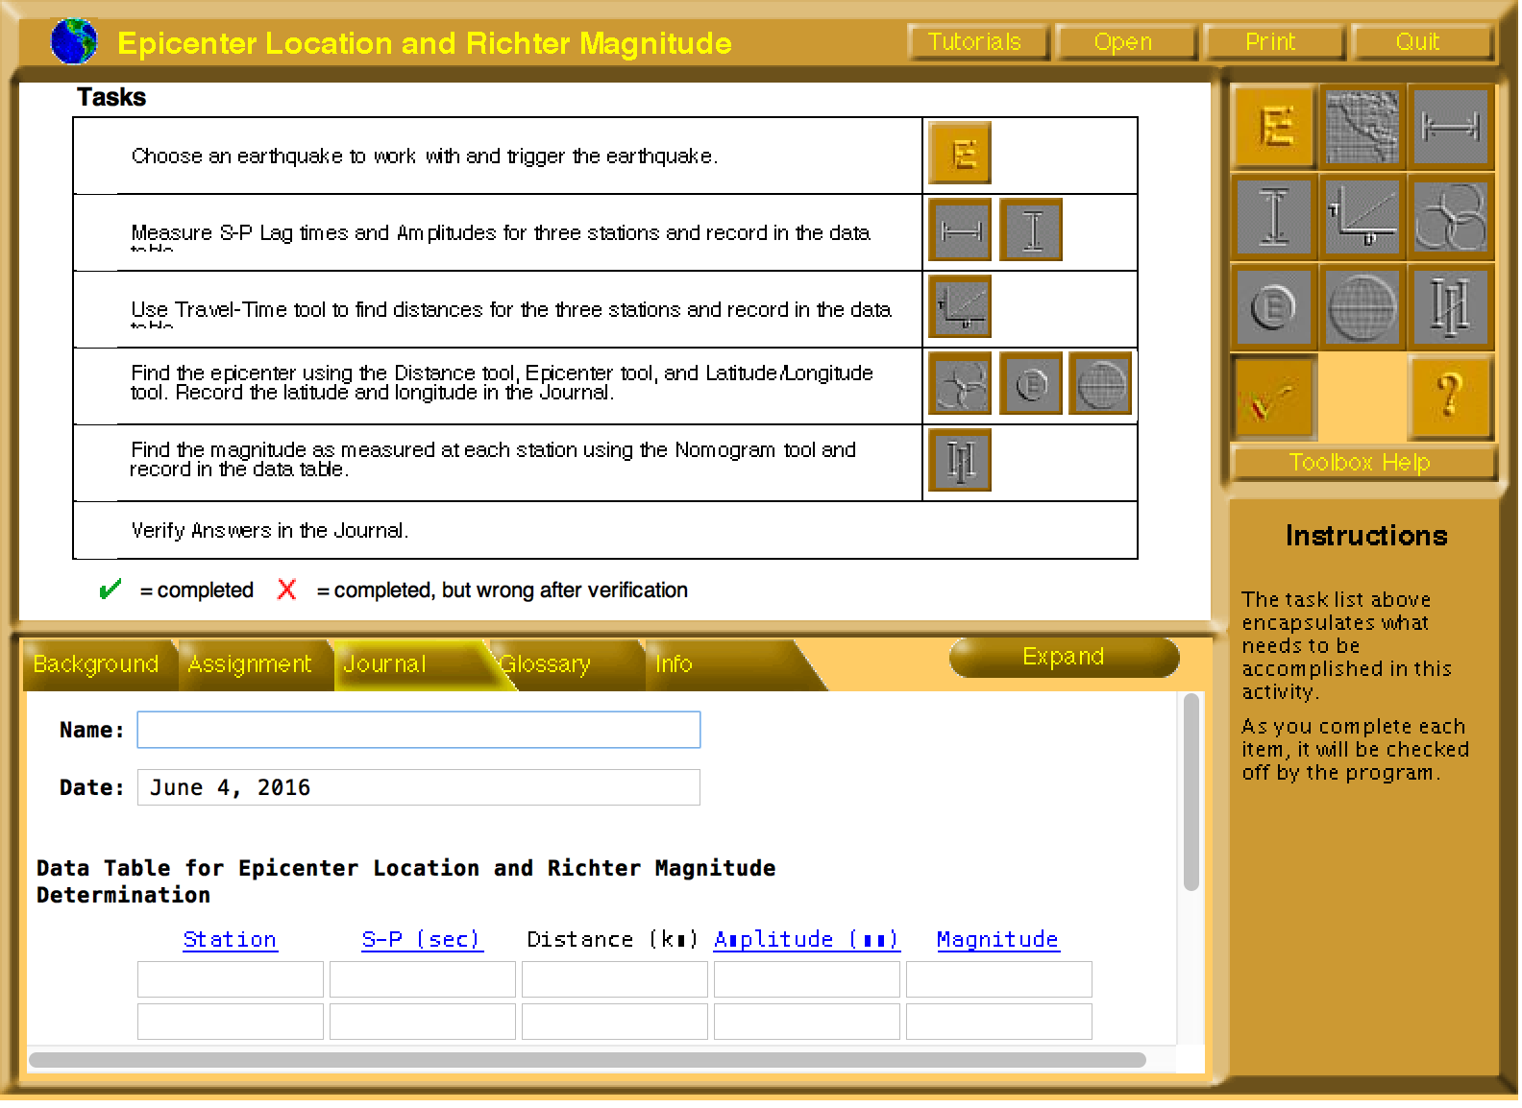

2. Right click on the page and inspect element. If the Inspect Element page does not pop up, try right clicking again in the white space of the page.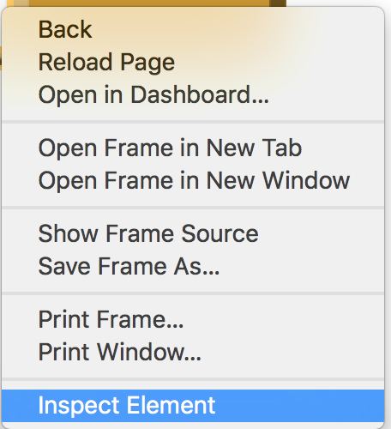

3. Find a tag called Applet, and look for an attribute called archive. That value is the .jar file we need to download.



***Note****: The attribute called codebase is the directory the jar file is stored.*

4. Go to the url that launched the Java applet and type in the codebase directory plus the jar file name.

5. If successful, you will have a copy downloaded to your computer.



6. Next, we need to find a decompiler for Java, and it is important to keep in mind that there are different decompiling softwares. In this example we will use a plug-in for Eclipse (<http://jd.benow.ca/>). Follow the instructions from this link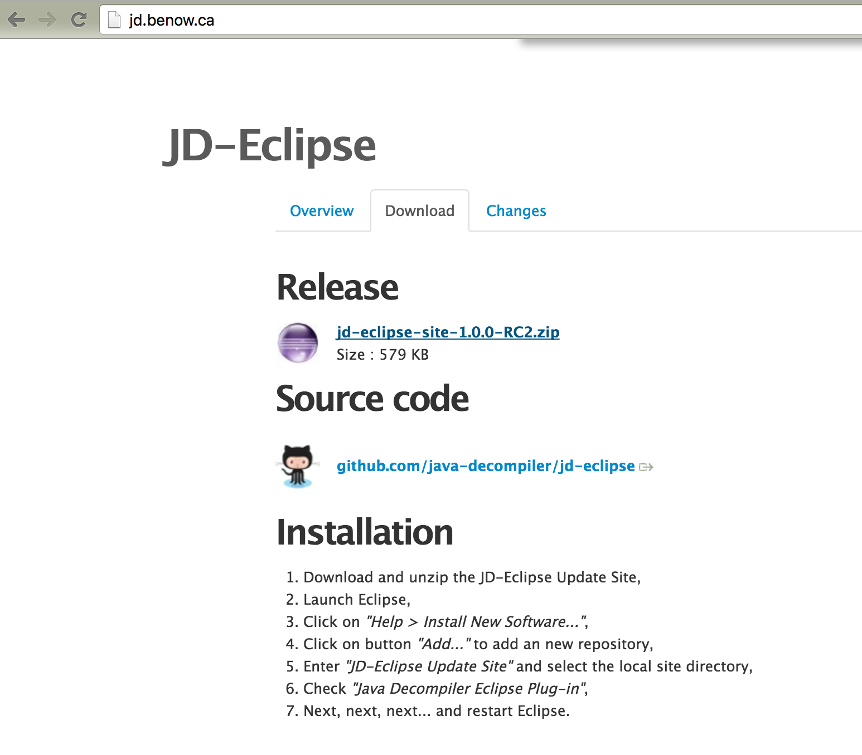

7. Restart Eclipse and create a new project called ExtractedApplet.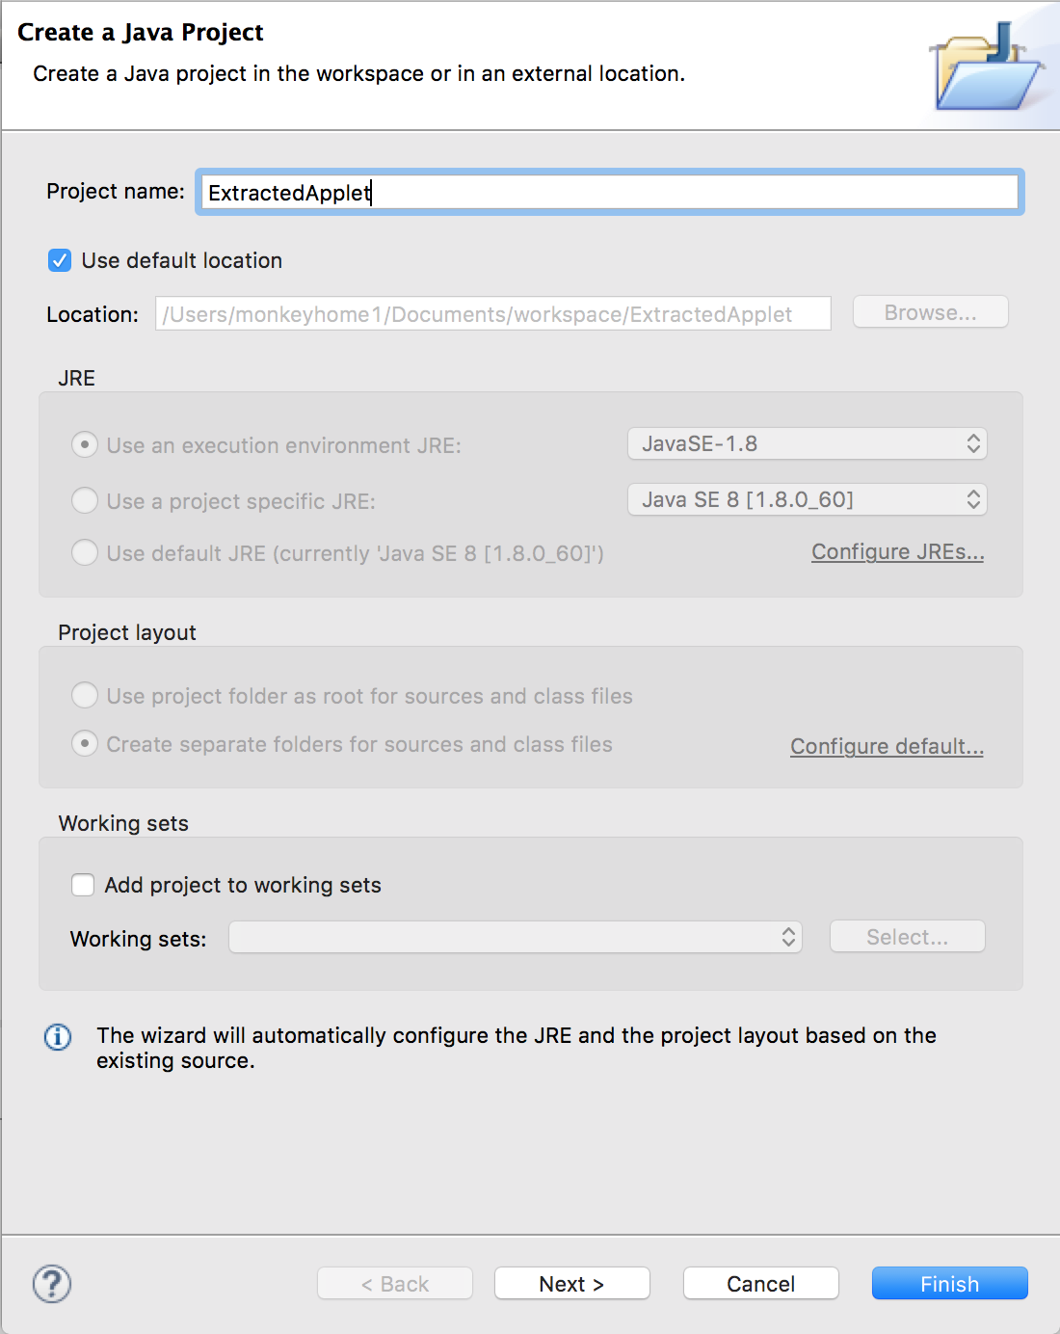

8. Right click the created project and choose Add External Archives under Build Path. Select the .jar file we want to add. This will add the downloaded jar file to your project.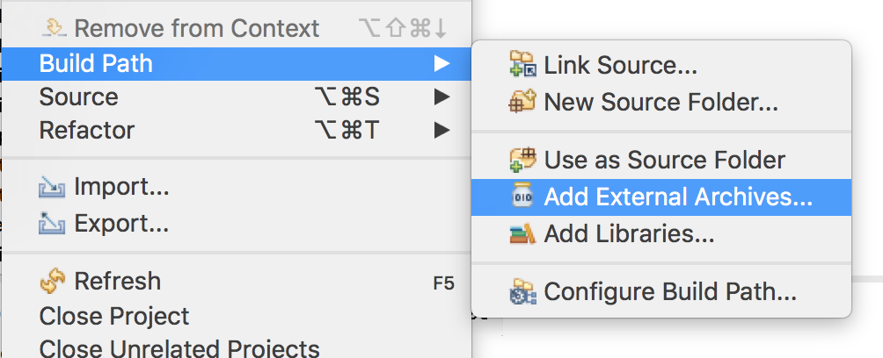

9. You can now expand the Jar file and double click on the class you want to decompile.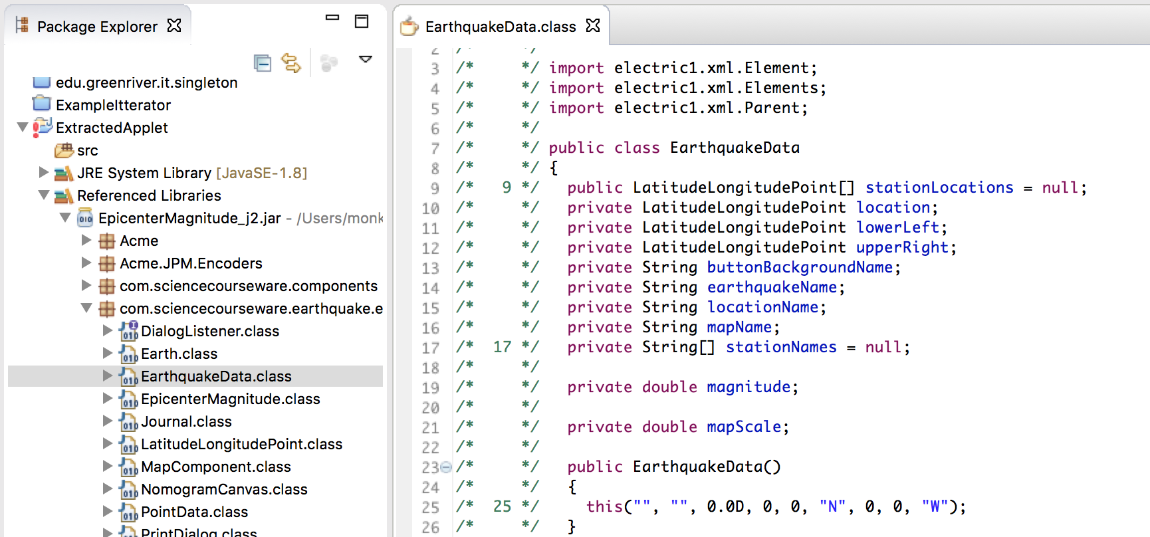

**Now you can extract the code and do what you want with it!**